Project 1

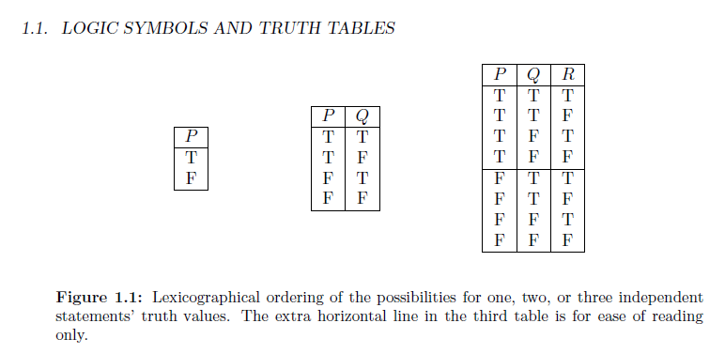

The assignment is to write a python program that will take the number of component statements and produce a lexicographical truth table for that number of statements.  Test your program with three and then 4 statements.   Because this is the first programing assignment I have given an example solution below. If you use it you must change the names of the variables, reenter it, show it works. And then submit a short explanation of why it works.

Do this in idle and send me your file.

If you need to download python you can do it here. I am using the Python 3.4 idle version.

<https://www.python.org/downloads/>

If you need a reference for python here is a good place to start.

Python tutorial

<https://docs.python.org/2/tutorial/introduction.html>

There is a partial explanation below the code. The code is from the idle environment and I am fine with that.

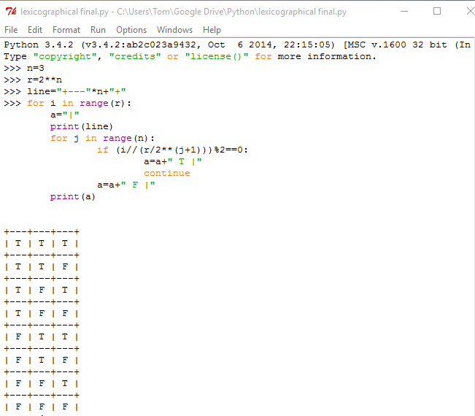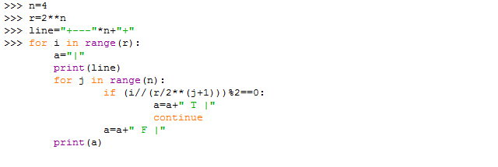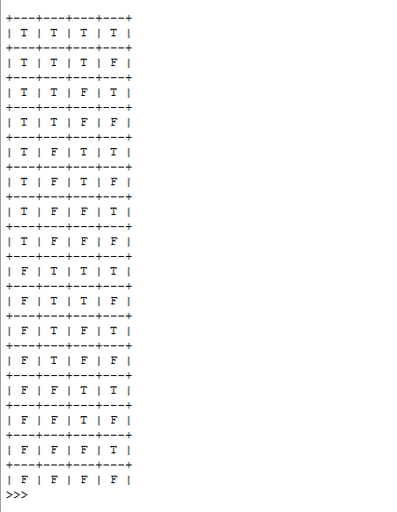

Each column repeats t or f some number of times

Left column alternates t and f

The one to its right repeats t twice then f twice

r/2\*\*(j+1) will give the number to times t repeats in the j column from the left. That is j=0 is the right most column. In the case above with 4 statements r=2\*\*4=16 is j=0 then 16/2\*\*1=8.

// is floor division so if the row number floor divided by the numbers of repeats is even or zero we have a T. Otherwise F.